# EExperienceEEE

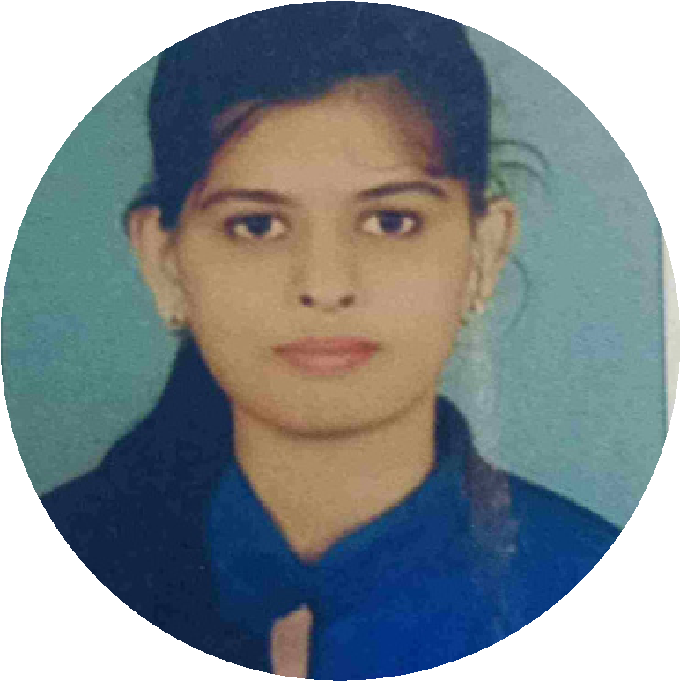

**PROFILE**

I consider my self a

responsible and orderly

person.

I am looking foward for

my first work

experience.

**CONTACT ME**

9421994853

swamijanhavi287@gmail.com

Chatrpati Chock

Nanded - 431602

**KEY SKILLS**

**Adaptability**

**EDUCATION**

**MASTER IN COMP APPLICATION(2021-2023)**

**HSC (2016-2018)**

**Score 56**

**LANGUAGE**

**English**

**COMPUTER SKILLS**

**CSS,**

**HTML,**

**JAVA , C**

**JANHAVI**

**HIREMATH**

*Student*

**PYTHON**

**Experience – D2h Telecaller – 2 month**

**Little scholor public School(6m)**

**cgpa 8.30**

**Bachelors comp Application (2018-2021**

)

**Score 76**

**SSC (2015-2016)**

**Score 66**

Hindi

Marathi

**EX**

**ea**

**Time Management**

**Communication Skills**